**First query**

Case 1:-

FIRST COMMAND IS TO VIEW THE DATABASE

The time taken by this query is 0.0002 sec.

Case 2:-

The time taken is 0.0002.

**Second query**

Case 1:-

SECOND COMMAND IS TO SELECT SOME COLUMNS FORM THE DATABASE THAT RETRIEVES THE ROWS AND SORTS THEM

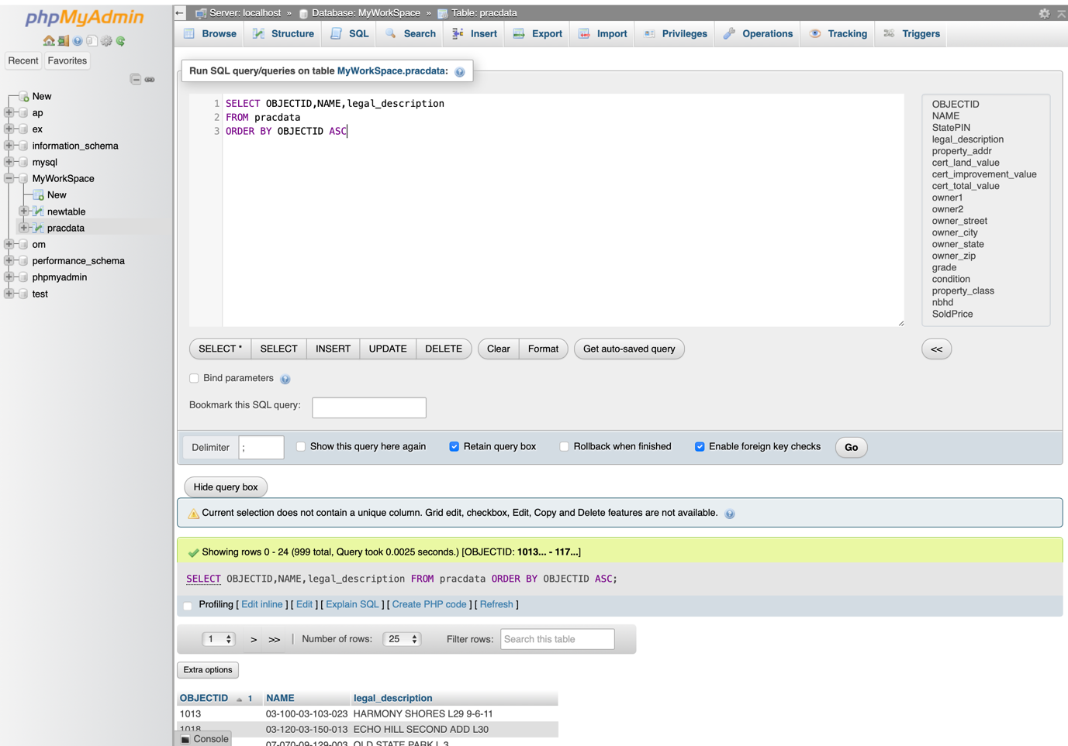

Time taken is 0.0025

Case 2:-

Time taken is 0.0002

**Third query**

Case 1 :-

THIRD COMMAND IS TO SELECT COLUMNS AND ADD THE VALUE AND STORE IN NEW COLUMN

Time taken is 0.0047

Case 2 :-

Time taken is 0.0005

**Fourth query**

Case1 :-

FOURTH COMMAND IS TO SELECT THOSE PROPRETIES WHOSE VALUES IS IN BETWEEN 1000000 TO 2000000

Case 2 :-

Time taken is 0.0059